**Problem 1:**

In the circuit below, find the average power (P) & reactive power (Q) supplied by the source.

Check that the average power (Watts) in the resistor, and the reactive power (VARs) in the capacitor are the same values as supplied by the source.

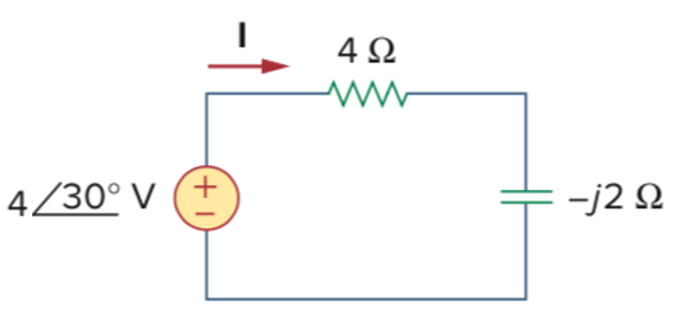

Problem 2:

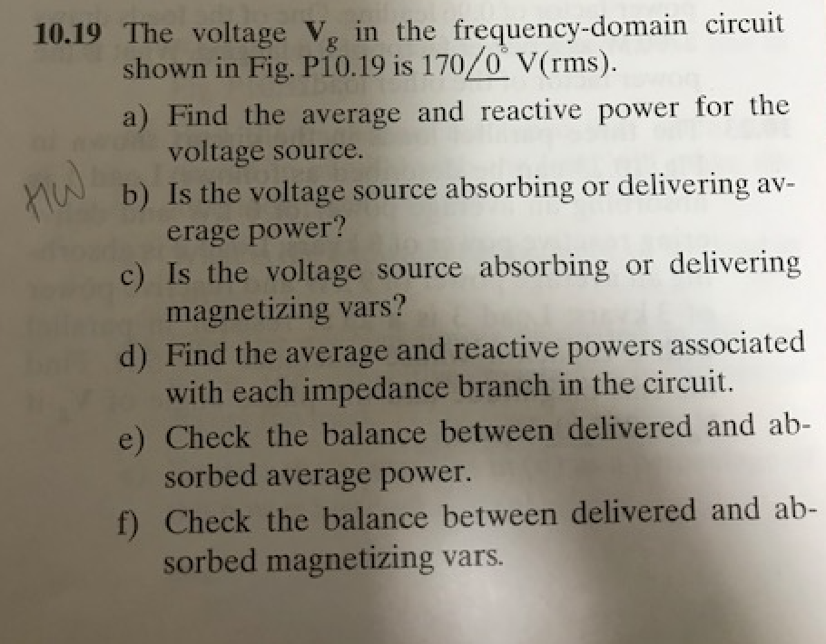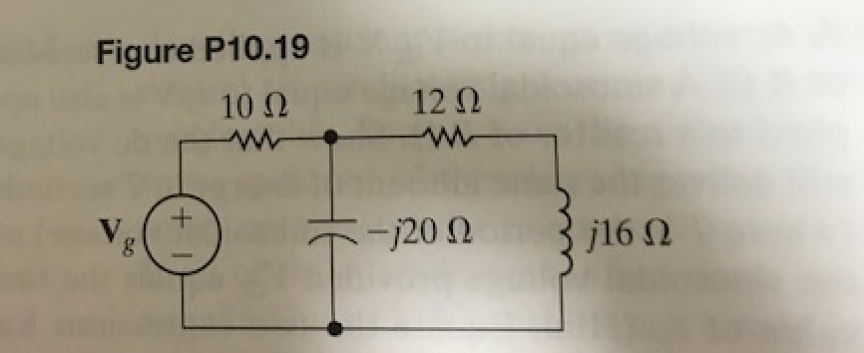

**Problem 3:**

When connected to a 120 V (rms), 60-Hz power line, a load absorbs 4kW at a lagging power factor of 0.8. Find the value of Capacitance, C, necessary to raise the power factor to 0.95 lagging.



**Problem 4:**

